A Weekend Couples Workshop in Midcoast Maine

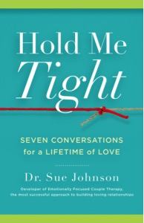
®

Conversations for Connection

- Would you like a closer connection with your partner?
- Do you find that you get stuck in repeated communication struggles?
- Would you like your relationship with your partner to be the best that it can be?

We all have a fundamental need to feel valued, understood, and loved by our partner. Research shows that ALL couples get disconnected at times, and that there is a reliable road map for reconnection when we get out of step with one another.

This weekend educational workshop for couples is based on the book “Hold Me Tight: Seven Conversations for a Lifetime of Love” by Sue Johnson. Participants workshop you will:
- Hear engaging presentations and watch video clips to learn the tools for creating and maintaining a life-long loving connection.
- Practice in private with your partner the conversations that will bring you closer together.
- Gain a deeper understanding of your own and your partner’s needs so that you can stay engaged and avoid getting derailed.
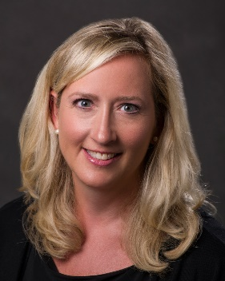
Theresa Cohen, LICSW is an experienced therapist certified in Emotionally Focused Couples Therapy (EFT). Her private practice is in Nantucket, Massachusetts
Julie Quimby, Ph.D. is a psychologist trained in Emotionally Focused Couples Therapy (EFT). She is the Founder and Director of Psychology Specialists of Maine

Date | Saturday & Sunday, April 27th and 28th, 2019
Time | Saturday, 8:30AM to 6:00PM Sunday, 8:30AM to 4:00PM
Location | Psychology Specialists of Maine, Fort Andross, 14 Maine Street, Suite 309, Brunswick, ME 04011
Cost | $695 per couple
For more information and online registration visit psychologyspecialistsme.com/couples-workshops/

